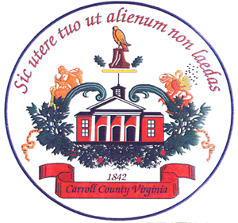

Carroll County Economic Development Authority
605-1 Pine St.
Hillsville, VA 24343
276-730-3009

AGENDA
11/17/21

- Call to Order, Larry Edwards, Chair

- Pledge and Invocation

- Citizens Time

- Minutes of:

  - 10/4/21

- Treasurers Report, Ms. Sandy West

  - Payment of Invoices

- Old Business

- New Business

- Closed Session

- Member’s Time

- Adjournment

